Given n non-negative integers representing an elevation map where the width of each bar is 1, compute how much water it can trap after raining.

Example 1:
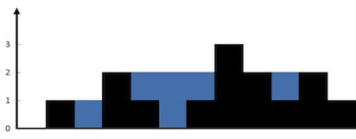
Input: height = [0,1,0,2,1,0,1,3,2,1,2,1]
Output: 6
Explanation: The above elevation map (black section) is represented by array [0,1,0,2,1,0,1,3,2,1,2,1]. In this case, 6 units of rain water (blue section) are being trapped.
Example 2:
Input: height = [4,2,0,3,2,5]
Output: 9
This is the approach
Math.min(leftMax , rightMax) – h[i]
APP: TC :O(3N) SC:O(2N) excluding resultant array
->compute the prevMax and suffMax from left and right respectively
->then compute the resultant as the min of the prev and suff – h[i]

class Solution {
public int trap(int[] height) {
int preMax[] = new int[height.length];
int suffMax[] = new int[height.length];
preMax[0] = height[0];
suffMax[height.length-1] = height[height.length-1];
for(int i = 1 ; i< height.length;i++)
preMax[i] = Math.max(preMax[i-1] , height[i]);

for(int i = height.length-2 ; i>=0;i--)
suffMax[i] = Math.max(suffMax[i+1], height[i]);

int res = 0;
for(int i = 0 ; i<height.length ; i++)
res += Math.min(preMax[i] , suffMax[i] )-height[i];
return res;
}
}

